**Name: Victoria Jacqueline Macías Pico**

**W O R K S H E E T S**

**NOTE:** **Your answers must be in blue and bold.**

# UNIT 2



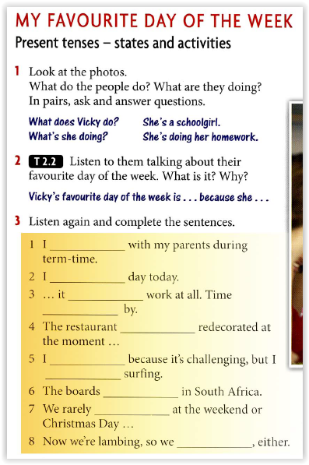

**Don’t live**

**’m having a very bad**

**Doesn’t feel like**

**Just flies**

**‘s being**

**Like my job**

**Live for**

**Are made**

**Have a day off**

**Aren’t getting any sleep**



**STATE VERBS**

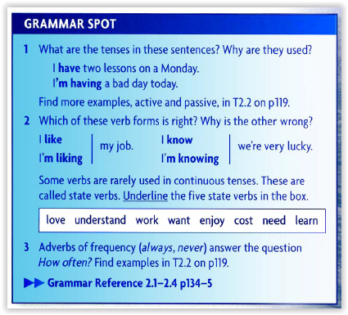

|  |  |
| --- | --- |
|  | **STATE VERBS** |
|  | **Love** |
|  | **Cost** |
|  | **Need** |
|  | **Understand** |
|  | **Want** |

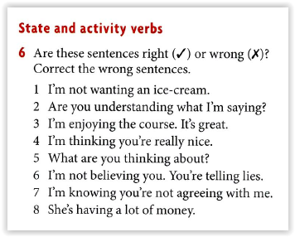

|  |  |
| --- | --- |
|  | **CORRECTION** |
|  | **I don’t want want an ice cream.** |
|  | **Do you understanding what I’m saying?** |
|  | **I’m enjoying the course. It’s great.** |
|  | **I’m thinking you’re really nice.** |
|  | **What are you thinking about?** |
|  | **I don’t believe you. You’re telling lies.** |
|  | **I know you don’t agree with me.** |
|  | **She has a lot of money.** |

**PASSIVE VOICE**

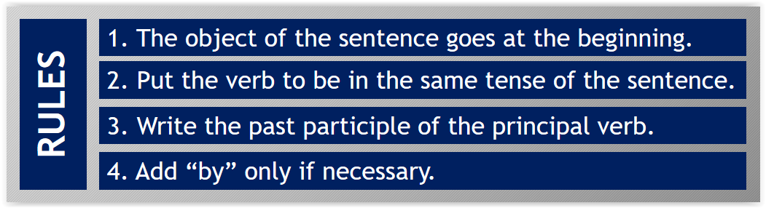

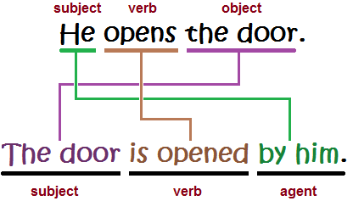

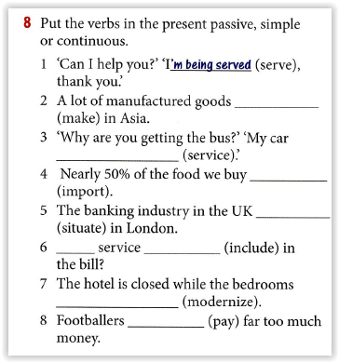

**Are made**

**Is being serviced**

**Is imported.**

**Is situated**

**included**

**Is modernized.**

**Are being paid**

**Is**

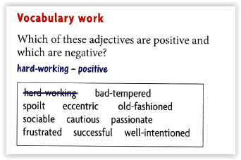

|  |  |  |
| --- | --- | --- |
|  | **POSITIVE** | **NEGATIVE** |
|  | **Hard working** | **Bad tempered** |
|  | **Sociable** | **Old fashion** |
|  | **Cautions** | **Eccentric** |
|  | **Passionate** | **Spoilt** |
|  | **Successful** | **Frustated** |